**MESD LMS Documentation – Categorize Courses**

**Purpose**

To facilitate the creation of courses, editing or moving a course, adding sub-categories, hiding categories and sorting categories.

**Background**

This module handles requests directly from Educators and Super Admins **(**IT officers at School level, Regional level, and Head -Q)within the Moodle system, allowing courses to be categorized.

**Usage**

**Adding a Course Category**

1. Login as an Educator or a Super Admin.
2. Go to ‘*Site Administration*’ > ‘*Courses*’ tab. Under the Courses category click on ‘*Manage courses and categories*’.
3. Click on the ‘*Create new category*’ button. Here you can give the category a name e.g. Mathematics. Add the category ID (If the ID is not required leave blank), and *Description*. Sub Categories can be set in the *Parent category* drop box. This is if the category is a sub category of an existing Category.

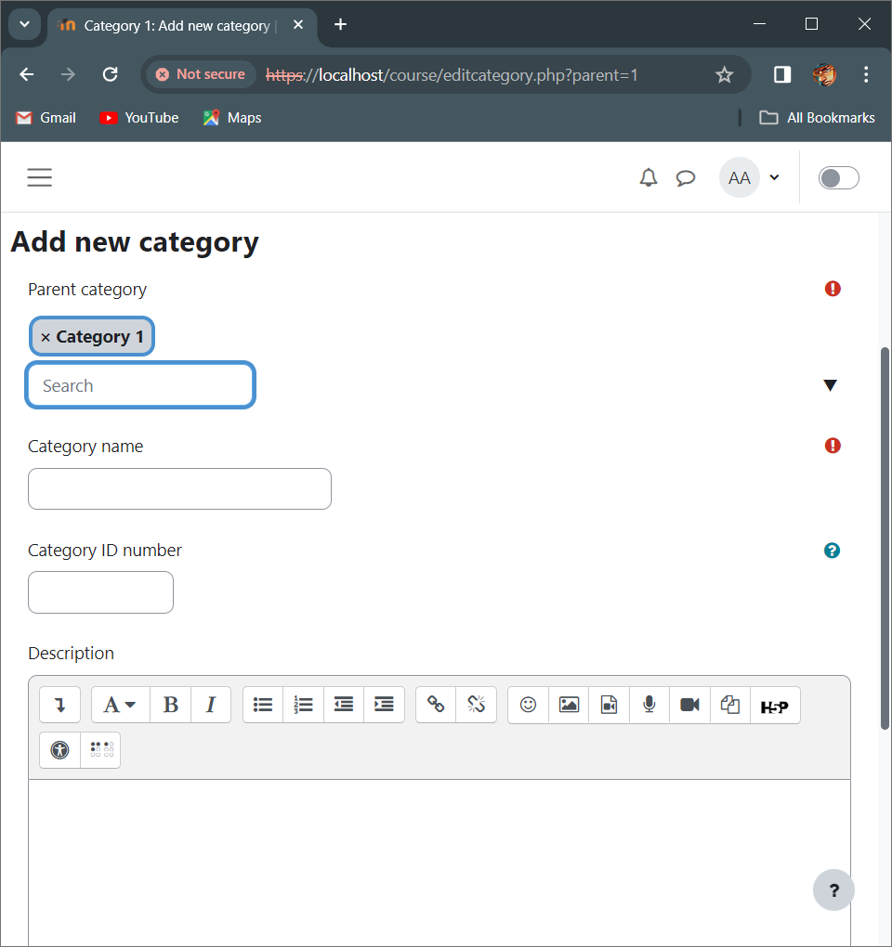

Click this drop down and select ‘Top’ to make this new category a main category.

Click on the X to remove the ‘Category 1’ from the main category.

4. When finished click ‘*Create Category’.*

**Editing or Moving a Category**

1. Login as an Educator or a Super Admin.
2. Go to ‘*Site Administration*’ > ‘*Courses*’ tab. Under the Courses category click on ‘*Manage courses and categories*’.
3. Editing a Category
   1. Search for the course or course category you want to edit.
   2. Click on the cog wheel icon to enter the edit page for the selected course.

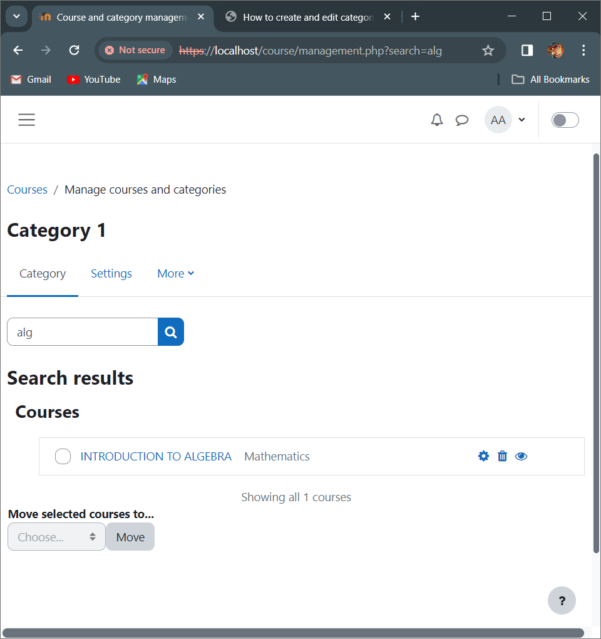

Click on this cog wheel to edit.

* 1. Proceed to edit the course then click on the *‘Save and display’* button at the bottom once done.

1. Moving a category
   1. You can move categories up or down by clicking the up/down arrow next to the category you wish to move. You can bulk move categories by checking the box to the left of their name and then by selecting from the dropdown *‘Move selected categories to’*.

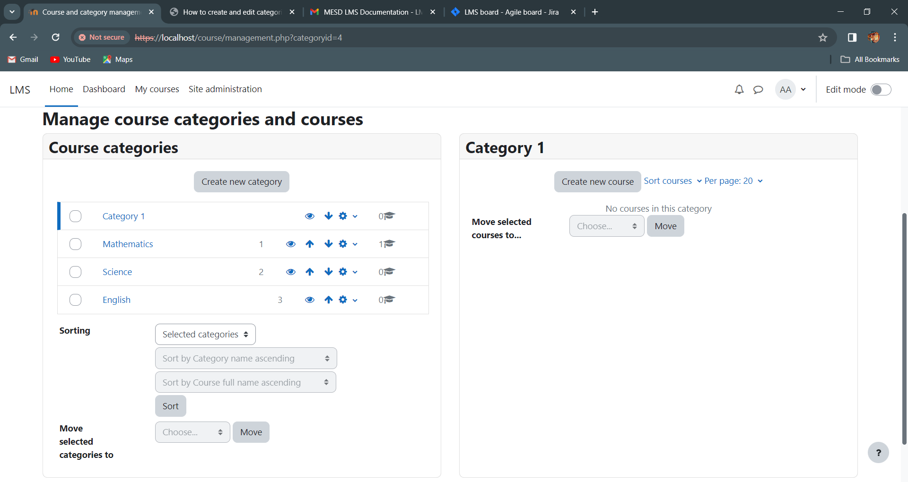

Number of courses within category

**Adding sub-categories (Categorizing courses)**

1. Login as an Educator or a Super Admin.
2. Go to ‘*Site Administration*’ > ‘*Courses*’ tab. Under the Courses category click on ‘*Manage courses and categories*’.
3. You can create a new, empty sub-category by clicking the actions icon next to its name and categories and selecting *'Create new subcategory'*.

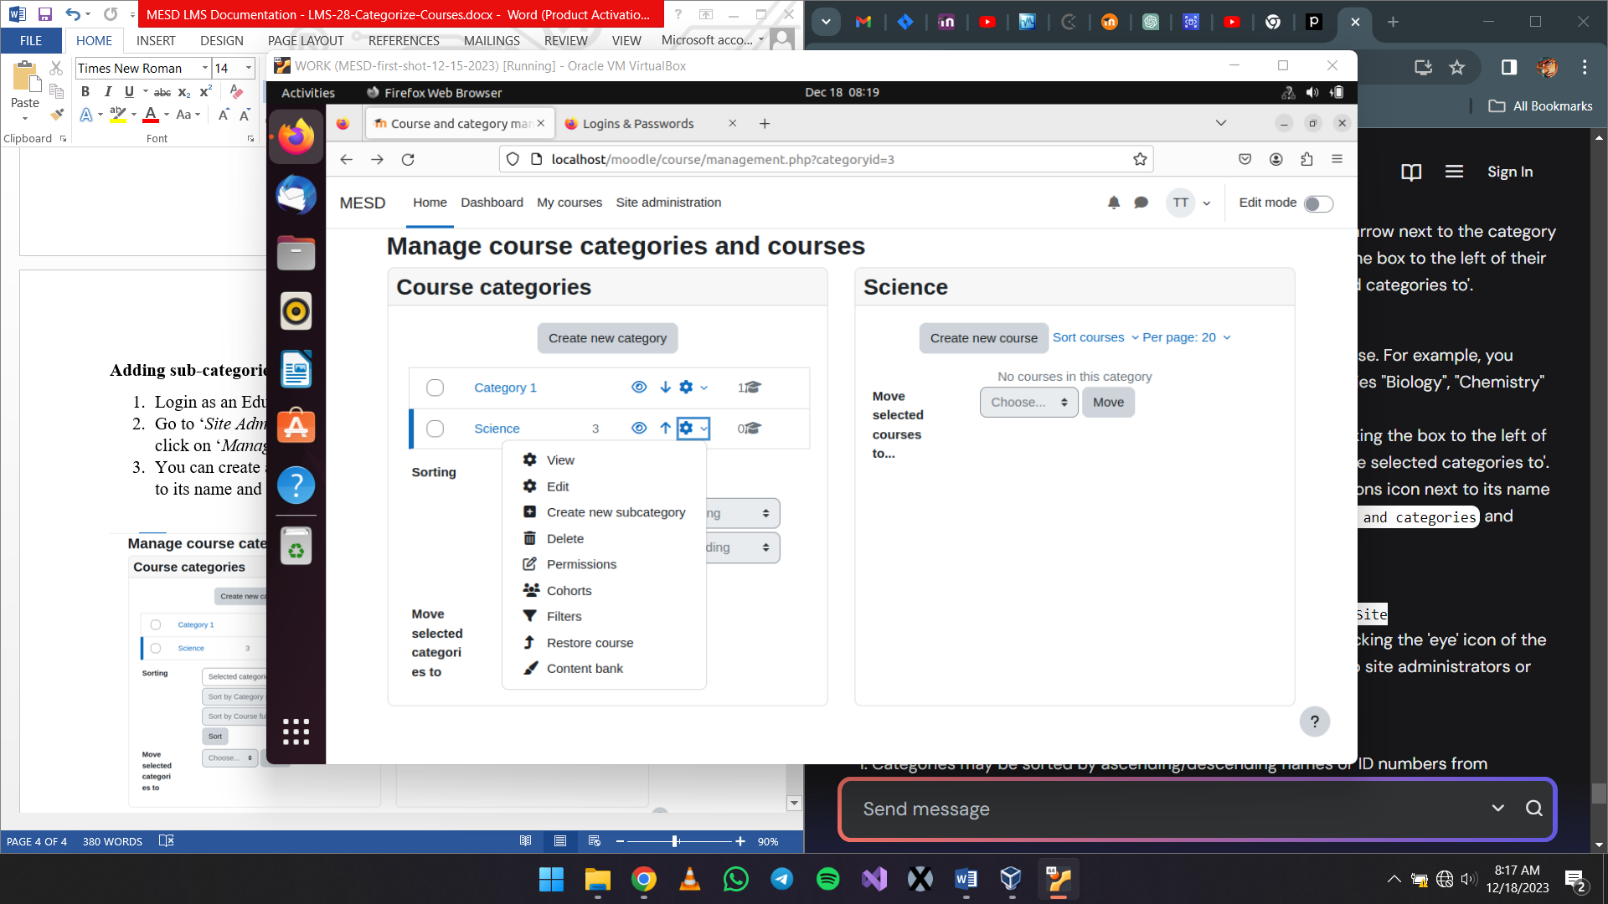

1. Click on *‘Create new subcategory’*.
2. Click on the actions icon.
3. Continue to create the new sub-category then save by clicking on *‘Create Category’.*

**Hiding Categories**

1. Under Site administration > Courses > Manage courses and categories.
2. Click the 'eye' icon of the category you wish to hide.

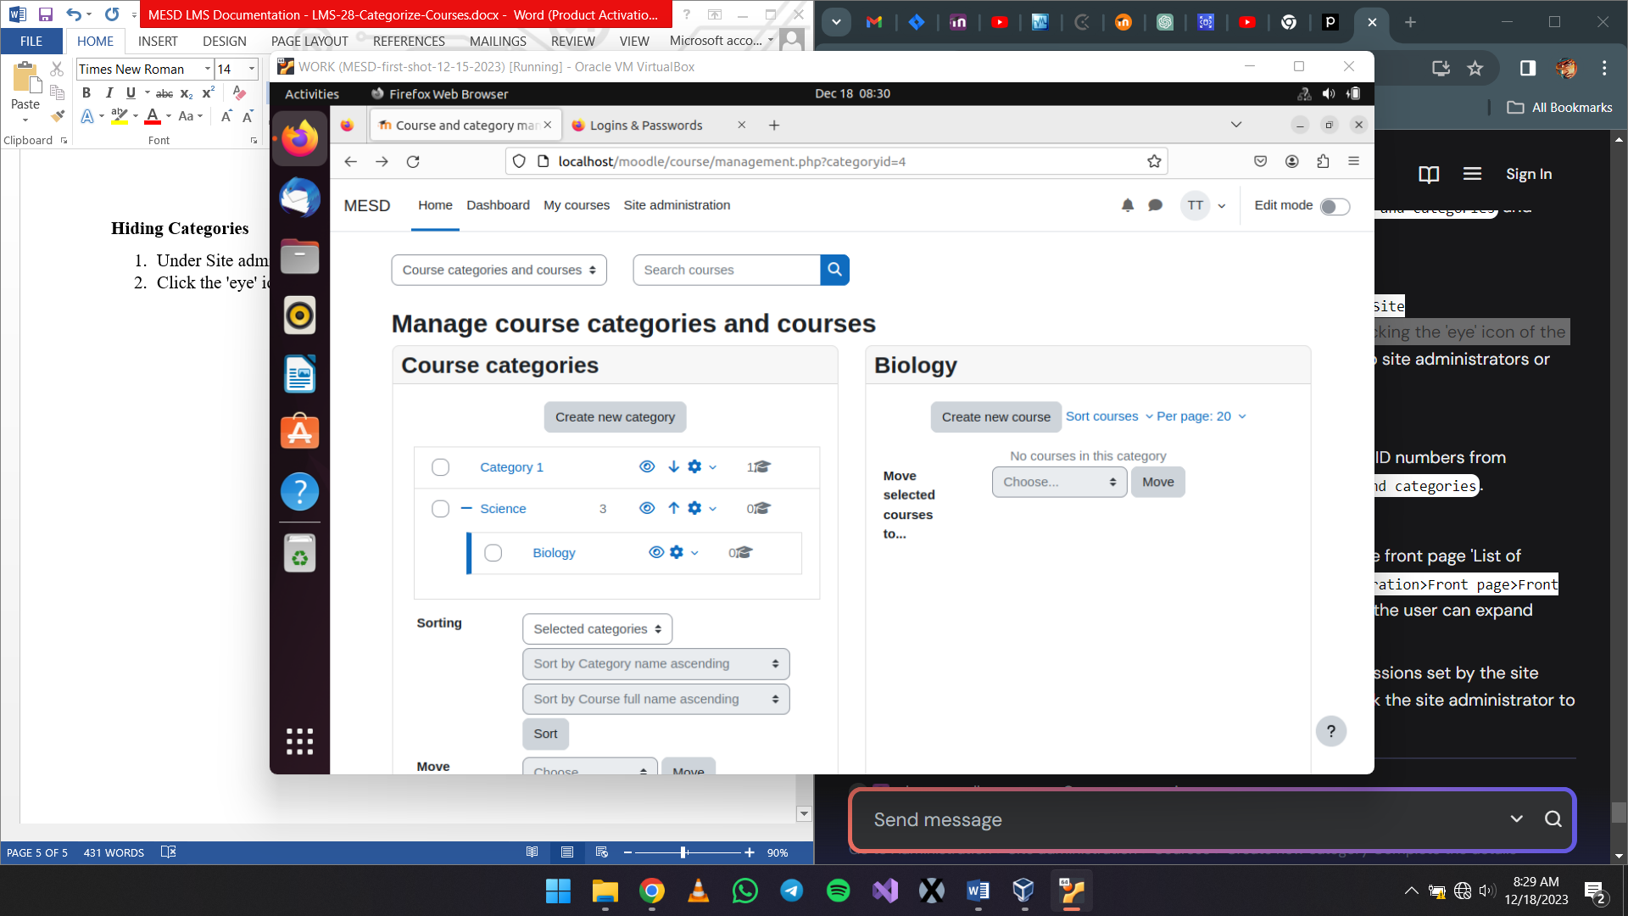

**Sorting Categories**

1. Under Site administration > Courses > Manage courses and categories.
2. Categories may be sorted by ascending/descending names or ID numbers.
3. Select what to sort.

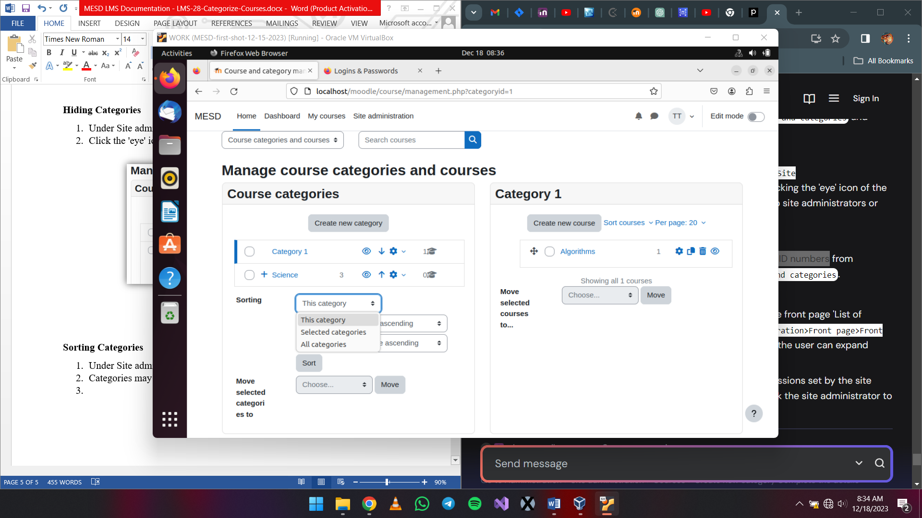

1. Select how to sort the courses and/or categories. Once done click on ‘Sort’

